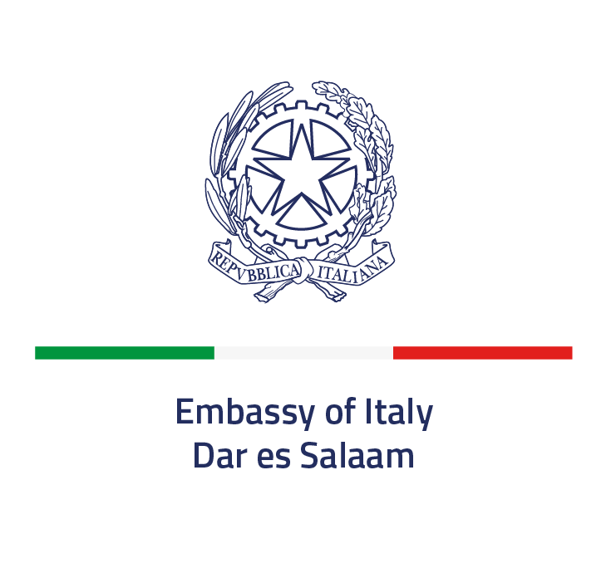
Embassy of Italy in Dar es Salaam
316, Lugalo road – Upanga
Dar es Salaam
E-mail: amm.dar@esteri.it

SPONSORSHIP OFFER

Subject: Sponsorship for the National Day celebrations and other events organized by the Embassy of Italy in Dar es Salaam

I, the undersigned ................................................... born on ................................ at .................................. as legal representative of the Company ...................................................................................................... based at ........................................................................................................................................................
Tel. .......................................................................... E-mail........................................................................

HEREBY DECLARES
- its interest in sponsoring the following event(s): ……………………………………………………...
………………………………………………………………………………………………………….
through one or more of the following forms of contribution:
(please tick one or more of the options of interest and provide the required details)
☐ Financial contribution, in the amount of ………………………………. (please specify the currency)
☐ Contribution in kind, consisting of ………………………………………………………………….
……………………………………………………………………………………………………………..
with an estimated economic value of ……………………………………... (please specify the currency)
☐ Contribution in services or performance of activities, consisting of ………………………………
…………………………………………………………………………………………………………….
with an estimated economic value of ……………………………………... (please specify the currency)

- to accept, without reservation or exception, the provisions and conditions set forth in the public notice regarding sponsorship opportunities published on the website of the Italian Embassy in Dar es Salaam for the year 2026, which they confirm to have read;
- to meet the participation requirements set out in the above-mentioned public notice;
- that none of the persons with powers of attorney in relation to the sponsor is subject to one or more conditions of exclusion pursuant to Article 94 of Legislative Decree 36/2023, with particular reference, but not limited to, the paragraphs relating to criminal convictions; the payment of taxes, duties, or social security contributions in the country of establishment, in Italy and in the country where the sponsorship takes place; the grounds for exclusion related to insolvency, conflict of interest, or professional misconduct; as well as the grounds for exclusion provided for by Italian law and equivalent situations under the legal system of the country where the sponsorship takes place;
- that none of the persons with powers of attorney is subject to impediments arising from anti-mafia legislation or from being subject to preventive measures;
- that the sponsorship activity intended to be provided is consistent with the scope of the sponsor’s business activity, as described in the relevant legal documentation / articles of incorporation of the legal entity / organization / company / association.

The undersigned representative formally declares that the information provided herein is true and accurate.
The undersigned hereby gives consent to the use of personal data solely for the purposes of the administrative and accounting purposes related to the sponsorship.

A copy of a valid identity document is attached.

Dar Es Salaam, ……………………….

Signature of the Authorized Person
…………………………………….

INFORMATION ON THE PROTECTION OF INDIVIDUALS WITH REGARD TO THE PROCESSING OF PERSONAL DATA according to Regulation (EU) 2016/679, art. 13
The personal data collection is processed in accordance with the principles of lawfulness, fairness, and transparency, in order to protect the fundamental rights and freedoms of individuals. To this end, the following information is provided:
Data controllers
The data controller is the Ministry of Foreign Affairs and International Cooperation (MAECI) of the Republic of Italy through the Embassy of Italy in Dar es Salaam, located at 316, Lugalo Road – Upanga, Dar es Salaam, tel.: +255 222115935 (switchboard), e-mail: segr.dar@esteri.it; certified email: amb.daressalaam@cert.esteri.it.
The MAECI has a data protection officer who, in case of questions or complaints, can be contacted at the following addresses: Ministry of Foreign Affairs and International Cooperation, Piazzale della Farnesina 1, 00135 ROME, tel. 0039 06 36911 (switchboard), e-mail: rpd@esteri.it; certified e-mail: rpd@cert.esteri.it.
Legal grounds for personal data processing
The personal data collected are processed for the purposes of carrying out a task of public interest and/or connected to the execution of public authorities vested in the Data Controller.
Purpose of processing
The processing of the data collected, including any photographs and/or video recordings, is for the following purposes: presentation of institutional activities.
Data collected:
The data collected are the following: name, surname, place and date of birth, residence, picture.
Methods of processing:
The data are processed by staff specifically appointed by the Data Controller. Data processing is carried out using a combination of automated and manual methods.
Mandatory or optional consent:
Consent is optional.
Data storage period:
The data collected are stored for the time strictly necessary to carry out the activities listed above.
Transfer of collected data to third parties and transfer of data to countries outside the EU:
The data may be shared via institutional accounts on the following platforms: Facebook, YouTube, Twitter, and Instagram. Please refer to the privacy policies of the respective platforms listed above for specific methods of data management, access, processing, and storage implemented by them.
User rights:
Under the conditions set out in the GDPR and Italian legislation (D.Lgs. 196/2003 and subsequent amendments and supplements) the user may exercise his rights regarding the processing of personal data by submitting a specific request to the Data Controller indicated above.
Complaints:
If a violation of privacy rights is detected, the user may submit a complaint to the MAECI's DPO. If the user is not satisfied with the response, he may also contact the Italian Data Privacy Authority - Piazza Venezia 11, 00187 Rome, tel. 0039 06 696771 (switchboard), e-mail: garante@gpdp.it, certified e-mail: protocollo@pec.gpdp.it or the judicial authorities.
Dar es Salaam, …………………………
Signature of the interested party for acknowledgement and acceptance
……………………………………………………………………….

